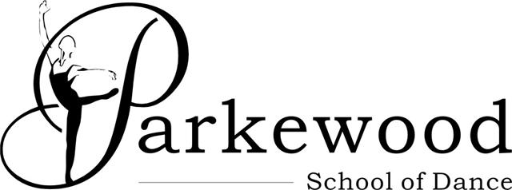

Dear Parents,

I would like to inform you that tickets for our show: Alice in Wonderland will be available for purchase outside the dance studio on Saturday 16th June 2018 from 11am and you will have the opportunity to select your seats yourselves. The Rose Theatre is smaller than Thornden Hall with a maximum capacity of just over 200 seats. At present we will be offering tickets in house (Tuesdays, Thursdays and Saturdays during classtimes) and should there be any surplus we will issue these to the general public. There will still be three performances: Saturday 14th July 7.30pm, Sunday 15th July at 3pm, Sunday 15th July 7.30pm.

Please bring this letter with you completed when purchasing your tickets as we will need to retain the bottom half of the letter as a record of your seating request. If you are unable to attend on Saturday 16th, then your order will be processed and the tickets returned to you via your child/ren’s class. Unfortunately we are unable to reserve seats, tickets will be on a first come first served basis. All cheques should be made payable to : L.Massey

All profits from the performances will be going to our chosen charity: the Murray Parish Trust, which raises funds for the Southampton Paediatric Intensive Care Unit at Southampton General Hospital. A representative from the charity will attend one of the performances to receive our fundraising cheque.

In the past I have always found it a good idea if not all members of the family go to the same performance, then the babies who are in the first act can go home and have a rest in between. Please also note when you would like to volunteer, as help is required for all performances.

All the children are having a lot of fun and working very hard over the past few weeks and everyone is now looking forward to an exciting and successful show weekend. Please give us as always your full support!

Yours sincerely
Lynne Wiltshire (Massey)
Principal

Childs Name:
Grade:
Ticket Allocation: | Adults £13 Child/OAP £11  (Please indicate if wheelchair user)
PERFORMANCE: | Seat Numbers:
Saturday 14th July 7.30pm
Sunday 15th July 3pm
Sunday 15th July 7.30pm
PAYMENT: | CASH CHEQUE*

- All tickets are non refundable and non-transferrable
- Please note children under three are not permitted and all children watching the performance must have seats for insurance purposes.

